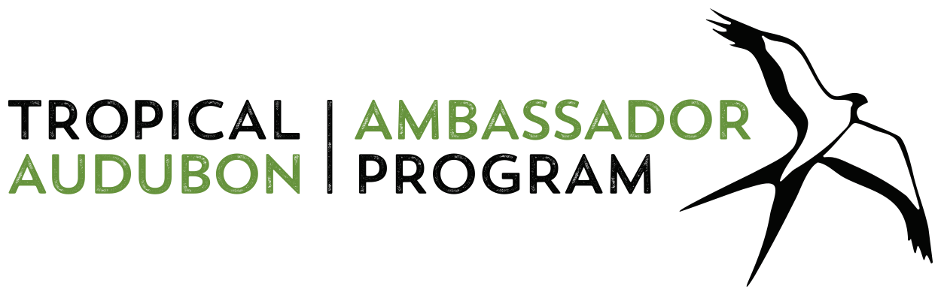

For Immediate Release

Tropical Audubon Ambassador Program
reimagined for Fall 2020 – Spring 2021

The award-winning education series designed to activate
environmental advocates goes FREE & Virtual

MIAMI, Fla. — South Floridians interested in becoming more engaged, educated and effective environmental advocates are invited to register for the 2020-2021 Tropical Audubon Ambassador Program. Participants in the free webinar series will receive advocacy training and come away armed with in-depth knowledge about Everglades Restoration, Smart Growth and Biscayne Bay. The program’s goal is to empower graduates to activate their “Tropical Audubon Ambassador” education on behalf of South Florida ecosystems.

Over the course of the 7-month Tropical Audubon Ambassador Program, students will learn about the most pressing threats to South Florida’s environment, how to engage in the Miami-Dade County civic process, and how to participate in effective environmental advocacy campaigns. Spring field trips (subject to COVID protocols) will connect Tropical Audubon Ambassador students to local environmental communities and expand their understanding of the ecosystems Tropical Audubon Society (TAS) works to protect.

Aspiring Tropical Audubon Ambassadors will matriculate with a network of like-minded environmental advocates and participate in deep-dive Q&As with regional experts in their fields. Additional benefits include access to a Facebook group, a monthly advocacy newsletter, action alerts on critical conservation issues, an online toolbox of resources and leadership development opportunities.

The 2020-2021 series is open to anyone 18 and older, as well as to past Tropical Audubon Ambassador graduates. All participants are required to first enroll in a “Civics” webinar series then choose up to three 5-part webinar “tracks” of interest — Biscayne Bay, Smart Growth and/or Everglades — and cap the program with a “Campaigns” webinar series.

Explore each topic with TAS Education Director and Tropical Audubon Ambassador Program Manager Alison Enchelmaier, who holds a Master of Science in Marine Affairs & Policy from University of Miami’s Rosenstiel School of Marine and Atmospheric Science. Live webinars will be offered monthly in each track. Recorded versions of the webinars will also be available. >

Tropical Audubon Society | 5530 Sunset Drive Miami, FL 33143 | (305) 667-7337 | www.tropicalaudubon.org

Tropical Audubon Ambassador Program, Page 2 of 3

Last year’s Tropical Audubon Ambassador Program was named the 2019 “Outstanding Education Program” by Audubon Florida, “For extraordinary commitment to building a new generation of advocates and conservation leaders.” The reimagined 2020-2021 program will build on that success and continue to engage community partners, among them conservation organizations including Audubon Florida, Catalyst Miami, The Everglades Foundation, Everglades Law Center, Miami Foundation, Miami Waterkeeper and the National Parks Conservation Association.

Additionally, the new program will be greatly enriched by experts from various fields of study
including Paul Schwiep and Richard Grosso, Smart Growth-focused attorneys; Manoj Shivlani, University of Miami Division of Marine Ecosystems and Policy; Irela Bagué, past chair of Miami-Dade County Biscayne Bay Task Force; and Tropical Audubon Society board members: Tiffany Troxler, Research Assistant Professor and Associate Director of Science, Sea Level Solutions Center, FIU; Gary Milano, Senior Environmental Scientist/Biologist and Habitat Restoration Specialist; and Terrence “Rock” Salt, former Deputy Assistant Secretary of the U.S. Army Corps of Engineers.

Tropical Audubon Ambassador Program Funding Partners: Thanks to the generous support of our underwriting partners — The Everglades Foundation, Miami Foundation and National Audubon Society — the Tropical Audubon Ambassador Program is now free.

Session Dates & Topics (Live Webinars 7-8pm)

Civics 101 Oct 29 & Nov 5, Nov 12
Biscayne Bay Nov 19, Dec 17, Jan 21, Feb 18, March 18
Smart Growth Dec 3, Jan 7, Feb 4, March 4, April 1
Everglades Dec 10, Jan 14, Feb 11, March 11, April 8
Campaigns 101 April 15, April 22, May 6

Required Webinars for all Ambassadors:
Civics 101: Gain knowledge and skills to participate more fully in public discourse and advocacy campaigns. Learn about Miami-Dade County’s government structure, as well as state and national institutions, and the roles, rights and responsibilities of community members. Get an overview of Everglades Restoration, the health of Biscayne Bay and local Smart Growth planning.
Campaigns: Learn how an environmental advocacy campaign works in this introduction to campaign strategy. How to develop a strategy for change, how to involve your community, supporters and detractors and the power of your personal story are among the topics to be covered. Gain hands-on experience by taking part in a live advocacy campaign planning webinar. >

Tropical Audubon Society | 5530 Sunset Drive Miami, FL 33143 | (305) 667-7337 | www.tropicalaudubon.org

Tropical Audubon Ambassador Program, Page 3 of 3

Program Tracks (Ambassadors may choose up to 3 tracks)
Biscayne Bay: Learn about our local water-quality issues and how you can become a voice for Biscayne Bay in this 5-part webinar track. Gain insights into local, state and federal laws and regulations that affect Biscayne Bay, the economic, cultural and ecological importance of this aquatic ecosystem, the multiple threats it faces and what can be done to address them, as well as opportunities to take advocacy actions to protect it.
Smart Growth: Delve into South Florida’s history of development and ways you can ensure a better future for our region in this 5-part webinar track. Learn how development policy decisions are made, how they drive growth and their implications for zoning, water quality and transit. Understand how growth impacts birds and other wildlife, communities and water resources, and take part in real-time advocacy campaigns.
Everglades: The history and science of the River of Grass, South Florida's most iconic and valuable ecosystem will be explored in this 5-part webinar track. Learn about development issues, water management and the power struggle over the control of water resources. Gain knowledge about the birds and other wildlife who depend on the Everglades habitats. Discover why this ecosystem is so important ecologically, culturally and economically to Miami-Dade County. Learn about the current threats to conserving this vital natural resource and actions you can take.
The Tropical Audubon Ambassador program is designed to complement the TAS Mission and methods: To conserve and restore South Florida ecosystems, focusing on birds, other wildlife and their habitats, with outreach centered around education and advocacy.

Registration Link: www.tasprograms.org/audubon-ambassador

For more programming information, contact:

Alison Enchelmaier at ambassador@tropicalaudubon.org

For media inquiries, contact:

Ana Lima at communications@tropicalaudubon.org

Tropical Audubon Society | 5530 Sunset Drive Miami, FL 33143 | (305) 667-7337 | www.tropicalaudubon.org

